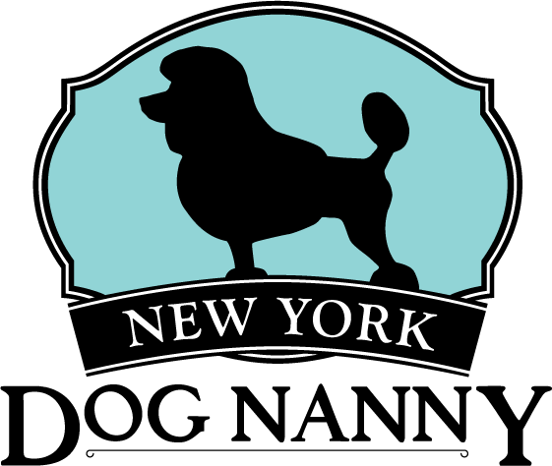
NEW YORK DOG NANNY - APPLICATION FORM

Welcome to the New York Dog Nanny Family! Thank you for your interest in partnering with us to provide manners, daily care and fun to your four-legged friend.

[ ] Proof of vaccination for Bordetella, DHPP and Rabies.
Please keep us updated with your dog’s Rabies, DHPP and Bordetella by emailing in a copy to info@Newyorkdognanny.com
Important Note: NYS law requires dogs in day care facilities to have Bordetella/Kennel Cough vaccination current within 6 months.

Dog’s Information
Dog Name: __________________________________ Breed: _____________________
Weight: ___________________ Birth Date: ____________________ Age: ___________
Gender: ___________________ SPAYED, NEUTURED or UNALTERED
Veterinary Clinic: ___________________

Vaccinations + BehAvior History
Please note that all vaccinations must be up to date (required upon check-in) for Rabies, D2HPP and Bordetella/Kennel Cough (within 6 months per NY State Law). Disclose ALL medical, emotional and behavioral issues prior to temperament test for safety of dogs and staff.

INSTRUCTIONS FOR EXTRA SERVICES (Pick-Up / Drop-Off)
Key location: doorman or NYDN facility
Instructions for pick-up/drop off?________________(bedroom, kitchen, lights)

OWNER’S INFORMATION
Full Name: ___________________________________ Cell Phone:_________________
Email: _______________________________________Work Phone:________________
Address: ________________________________________________________________
City: __________________________ State: ______________ Zip: _________________

Emergency Contact
Name: ____________________________________________ Cell: _______________________
PAYMENT INFORMATION (REQUIRED)
Card #: _______________________________________________ (VISA, DISCOVER, MC)
Expire Date: _____/_____/_____Billing Address: __________________________Zip Code: _______
Tip Amount: 10% 15& 20% 25%_________________ (will be applied to each bill, after services)

NEW YORK DOG NANNY: Client Service Agreement

TIPS + NON-COMPETE
- New York Dog Nanny is recognized as a professional pet service provider and I understand that it is customary to tip between 15-20% for all services rendered.
- I appreciate, respect, and understand that New York Dog Nanny goes through extensive hiring, background check, and training processes to bring the most qualified professionals to care for my pet(s). I agree to not hire or schedule or contact any of the staff members I’ve met through the company during or after services rendered for a minimum of 1 year after services or staff is terminated, whichever is longer.
HEALTH / BEHAVIOR
- I understand that NY DOG NANNY reserves the right to refuse training, services, or use of the facility for dogs who, in its sole determination, are unhealthy, act aggressively, are undisciplined, or who may be otherwise a danger to themselves or other animal users.
- Proof of current vaccinations must be on file for DHPP, Rabies, and Bordetella. Please note, NYS law requires dogs that visit daycare facilities to have Bordetella re-administered every 6 months. It is the client’s responsibility to ensure their pet is up to date and gives permission to NYDN staff to bring pets to the vet to stay current on shots.
- I acknowledge that I take responsibility for, and will not hold NY DOG NANNY liable for, any injury, illness or ailment which my dog may incur while in the presence of other dogs at the facility or otherwise.
- All dogs must wear a harness or properly fitting collar at all times to ensure safety of all dogs, if one is not provided at time of service commencement, one will be provided at owner expense of $6.95.

DAYCARE
- Full day dog daycare guests under the age of 1 are fed owner provided food.
- Please bring pre-packaged food in a zip-lock bag at check-in each day. If we are providing pick up services for your pet, we can hold your dog’s lunch supply beginning on Monday for 1 week at a time only.
VETERNARTY CARE / VET RELEASE
- If my dog becomes ill or if the state of my dog’s health otherwise requires professional attention, NY DOG NANNY, in its sole discretion may engage the services of a veterinarian, administer medicine, or give requisite attention to my dog.
- I give my consent to NY DOG NANNY to act on my behalf in obtaining emergency or any other care at my own expense if deemed necessary by NY DOG NANNY or any of its staff.
- Please Note: If vet services are needed we use our recommended vet, Murray Hill Pet Hospital, Dr. Dan. There is a vet visit fee: $15.00, which will be applied to your invoice, including final vet bill.

PAYMENTS / CREDIT CARDS
- I authorize NY DOG NANNY to maintain my credit card information on file and charge for purchases and services either at the time a reservation is made, a package is purchased, or my dog is checked into NY DOG NANNY for service.
- I also authorize NY DOG NANNY to use my credit card to charge me for any late fees or additional fees resulting from my dog’s stay with NY DOG NANNY at the conclusion of rendered services.
- I agree to pay the rate for the daycare, boarding, grooming, training and all other services provided by NY DOG NANNY after receiving an invoice (if any).
- I acknowledge and agree that NY DOG NANNY will decline services to my dog if I have any overdue unpaid balance resulting from services rendered.
- Due to safety and staffing purposes, NY DOG NANNY reserves the right to charge a late fee for pick-ups from the daycare or boarding after closing hour. ($5 fee per 15 min). Max wait time 30 mins then boarding rates will apply
- All clients must supply a valid credit card to be kept on file. Failure to pay invoices within 1 month will result in client invoices sent to collections.

packages
- 10, 15, 20 daycare packages are valid for 3 months from purchase date ANd ARE SET TO AUTO-RenEW. 30 day daycare package is valid for 6 months from purchase date. All packages are put on auto-renew unless specified otherwise.
- boarding packages do not include holiday fees which are $10/day over the holiday weekend and valid 1 year from expiration date unless otherswise specified. Dogs boarding more than 7 days must pre-pay for first 7 days.
LIABILITIES
- I specifically represent that I am the sole owner of my dog, free and clear of all liens and encumbrances.
- This contract contains the entire agreement between the parties. All terms and conditions of this contract shall be binding on their spouses, heirs, administrators, personal representative, and assignees of me, and NY DOG NANNY.
- Any controversy or claim arising out of or relating to this contract, or breach thereof, or as a result of any claim or controversy involving the alleged negligence by any party to this contract, shall be settled by arbitration in accordance with the rules of the American Arbitration Court having jurisdiction thereof. The arbitrator shall, as a part of his/her award, determine an award to the prevailing party of the costs of such arbitration and reasonable attorney’s fees of the prevailing party.
- By signing this contract and leaving my dog with NY DOG NANNY, I certify the accuracy of all the information I have provided to NY DOG NANNY relating to my dog.
- I agree I am responsible for my dog being up to date with Rabies, DHPP and bordatella (every six months) and assume any fines for not keeping NYDN up to date.
X________________________________________________________________________
Parent’s Signature

